Name: Christian Alvarez
Date: October 26, 2025
Class: IT2249
Unit: U3D1 Validate Course Code

Source Code
1. package u4a1_validatecoursecode;
2.
3. import java.util.Scanner;
4.
5. /
6. * @author christian
7. *
8. * psudocode:
9. * 1. prompt user to enter a course code
10. * 2. read course code from user
11. * 3. validate course code using the following rules:
12. * a. must be exactly 6 characters long
13. * b. first 2 characters must be letters
14. * c. last 4 characters must be digits
15. * 4. if course code is valid, print "Valid course code"
16. * 5. if course code is invalid, print "Invalid course code"
17. *
18. */
19.
20. public class U4A1_ValidateCourseCode {
21.
22. // validation function
23. // use String.format() to format messages
24. public static String validateCode(String code) {
25. // check if the string is null
26. // fix: use isEmpty() method to check for empty string instead of "== null"
27. if (code.isEmpty()) {
28. return "Course code is invalid: Cannot be null.";
29. }
30.
31. // collect all validation messages
32. StringBuilder error = new StringBuilder();
33. boolean isVaid = true;
34.
35. // check length of the string
36. if (code.length() != 6) {
37. return String.format("Course code '%s' is invalid: %nMust be exactly 6 characters long.", code);
38. }
39.
40. // check string for invalid characters using for loop
41. // return a message for each condition that is met or not met
42. // each case checks a specific character in the string
43. for (int i = 0; i < code.length(); i++) {
44. char c = code.charAt(i);
45. switch (i) {
46. // case 0 & 1 check if the first two characters are 'I'/'i' and 'T'/'t' respectively
47. // case 2, 3, 4, & 5 check if the last four characters are digits
48. case 0:
49. if (c != 'I' && c != 'i') {
50. error.append("First character must be 'I' or 'i'.");
51. isVaid = false;
52. }
53. break;
54. case 1:
55. if (c != 'T' && c != 't') {
56. error.append("Second character must be 'T' or 't'.");
57. isVaid = false;
58. }
59. break;
60. case 2:
61. if (!Character.isDigit(c)) {
62. error.append("Third character must be a digit (0-9).");
63. isVaid = false;
64. }
65. break;
66. case 3:
67. if (!Character.isDigit(c)) {
68. error.append("Fourth character must be a digit (0-9).");
69. isVaid = false;
70. }
71. break;
72. case 4:
73. if (!Character.isDigit(c)) {
74. error.append("Fifth character must be a digit (0-9).");
75. isVaid = false;
76. }
77. break;
78. case 5:
79. if (!Character.isDigit(c)) {
80. error.append("Sixth character must be a digit (0-9).");
81. isVaid = false;
82. }
83. break;
84. }
85. {}}
86.
87. // returns a message based on validation result
88. // error messages are appended to reuturned string
89. if (isVaid) {
90. return String.format("Course code '%s' is valid.", code);
91. } else {
92. return String.format("Course code '%s' is invalid: %n%s", code, error.toString().trim());
93. }
94.
95. }
96.
97. public static void main(String[] args) {
98. // create scanner instance
99. Scanner scn = new Scanner(System.in);
100.
101. // prompt user enter a course code
102. System.out.print("Enter a course code to validate(e.g. IT4782): ");
103. String courseCode = scn.nextLine();
104.
105. // validate course code using validate function and print result
106. String result = validateCode(courseCode);
107. System.out.println(result);
108.
109. // close scanner
110. scn.close();
111. }
112.
113. }
114.
Screenshots
Failing Test
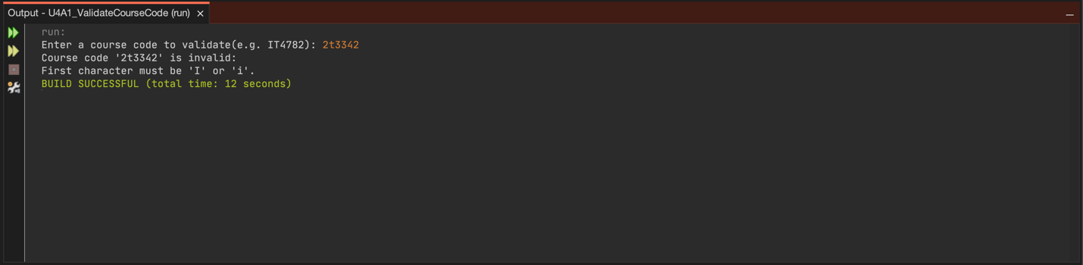
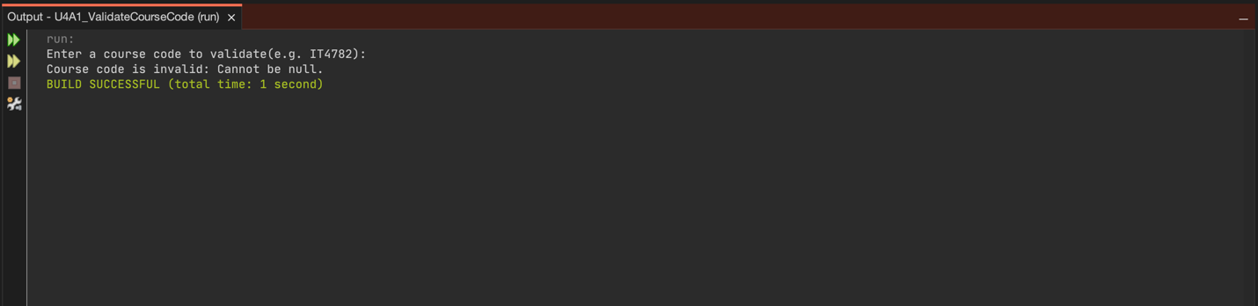
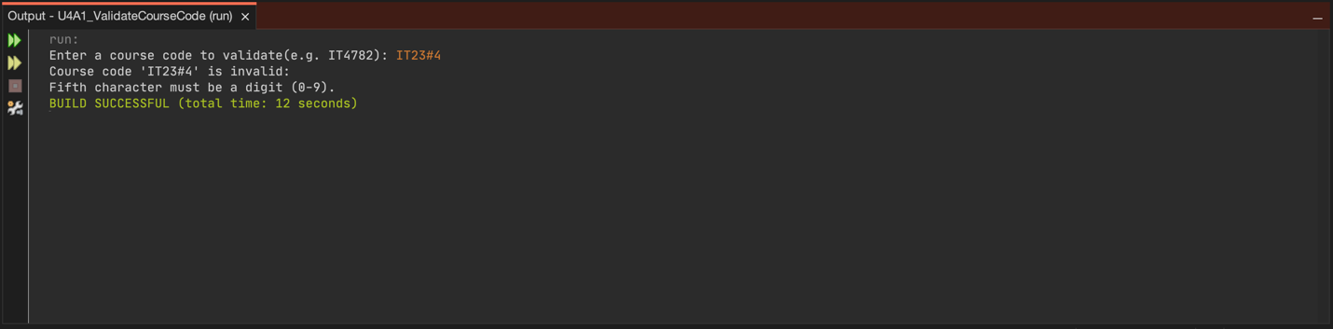

Passing Test
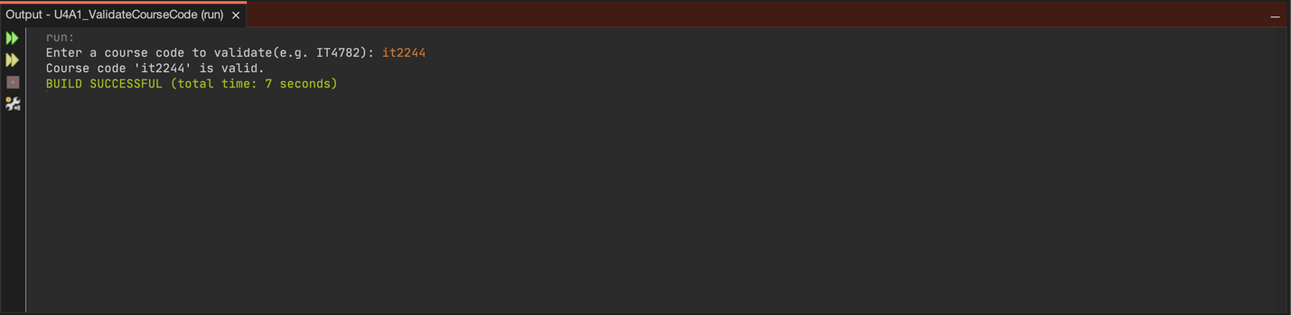
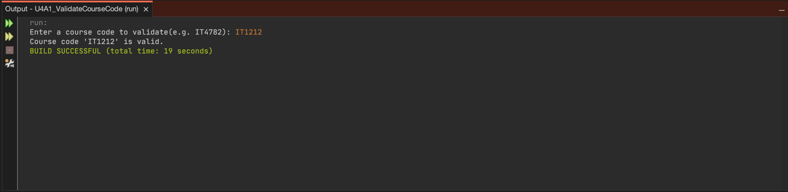

Explanation
Bugs Identified and Fixed
This project presented several significant challenges, particularly with logic implementation. The primary bugs I encountered and fixed included issues with null check validation, validation logic structure, and error message accumulation. Initially, I tried to use code == null to check for empty strings, but this approach does not work for empty strings in Java; I resolved it by using the isEmpty() method, which correctly determines whether the string contains no characters. The validation logic structure was the most time-consuming bug, as my original method for checking each character position lacked organization and made it difficult to deliver clear and specific error messages. To address this, I reorganized the validation process by implementing a switch statement within a for loop, allowing the program to systematically verify each character's validity and provide detailed feedback about any invalid entries. Another notable issue involved accumulating and displaying error messages; I had to incorporate a StringBuilder to collect multiple validation errors and a boolean flag (isVaid) to monitor the overall validation state. This aspect required significant debugging to ensure all error conditions were accurately captured and formatted in the final output message.

Approach and Testing
I began by reviewing the assignment requirements to understand the exact validation rules: six characters total, first two must be 'IT' (case-insensitive), and last four must be digits. I then outlined the pseudocode before implementing the actual code.
The debugging process consumed most of my time on this project, particularly working through the logic implementation bugs. I used NetBeans IDE to identify syntax errors initially, but the logic errors required extensive testing and careful thinking through each validation scenario. I had to trace through the program execution mentally and with test cases to understand why certain validations weren't working as expected.
My testing strategy included multiple scenarios:
Test 1: Empty input to verify null/empty checking
Test 2: Input "2t3342" to test first character validation
Test 3: Input "IT23#4" to test digit validation for different positions
Test 4: Input "it2244" to verify valid lowercase input works
Test 5: Input " IT1212" to verify valid lowercase input works
Additional tests: Codes with wrong length, all wrong characters, and proper valid codes like "IT4782"
Each test revealed aspects of the logic that needed refinement. The switch statement approach finally provided the clarity I needed to properly validate each position and generate appropriate error messages.
Programming Constructs Used
This program demonstrates several important Java programming concepts:
String manipulation: The program uses methods like `isEmpty()`, `length()`, and `charAt()` to analyze the input string character by character.
Character validation: The `Character.isDigit()` method checks whether characters are numeric digits, which is essential for validating the last four positions.
Control structures: The switch statement within a for loop provides a clean way to handle position-specific validation logic. Each case corresponds to a specific character position (0-5) and applies the appropriate validation rule.
StringBuilder: This class efficiently builds the error message string by appending multiple error descriptions as validation failures are discovered.
Boolean logic: The `isVaid` boolean flag tracks whether all validations pass, allowing the method to return a success or failure message appropriately.
String formatting: The `String.format()` method creates well-formatted output messages with proper line breaks (`%n`) and variable insertion (`%s`).
Method design: The `validateCode()` method encapsulates all validation logic, making the main method clean and focused on input/output operations.
Reflection
This assignment was much more challenging than previous tasks due to its complex validation logic. I learned the importance of breaking down validation into manageable checks and found that using a switch statement clarified the logic once implemented. Debugging focused more on logical errors than syntax, requiring careful structuring of nested checks and error message accumulation. Handling case-insensitive validation, working with the StringBuilder class, and deciding how to provide feedback for errors were notable challenges that required research and multiple iterations. Through systematic testing and analysis, I realized logical bugs are harder to spot since programs can run but yield incorrect results.
This experience reinforced best practices like writing pseudocode, testing edge cases, using meaningful variable names, and dividing complex problems into smaller functions. Learning to be patient with logic bugs and approaching debugging methodically will help me tackle future programming challenges more effectively.

